**Project Design Phase-II**

**Data Flow Diagram & User Stories**

|  |  |
| --- | --- |
| Date | 16 April 2025 |
| Team ID | SWTID1744468652 |
| Project Name | i-movies : movie ticket booking system |
| Maximum Marks | 4 Marks |

* **User (Customer):** Registers or logs in, searches for movies, selects show timings, books tickets, and makes payments.
* **User Registration & Login:** Handles account creation, secure authentication using JWT, and session management. Communicates user account data to the system backend.
* **Movie Browsing & Search:** Enables users to view currently available movies, search by genre/language, and fetches movie data from the database.
* **Show Selection & Seat Booking:** Users can select a specific movie, show timing, and choose available seats. This data is sent to the backend for processing and seat locking.
* **Ticket Booking & Checkout:** Collects selected show, seats, and user data, initiates payment via the integrated Payment Gateway (like Razorpay), and sends ticket booking info to Booking Management.
* **Booking Management:** Stores ticket details, assigns booking ID, updates seat availability, and sends confirmation to the user.
* **Administrator:** Manages movie listings, updates showtimes, monitors bookings, and resolves user issues from the admin dashboard.
* **Payment Gateway:** Facilitates secure transactions and returns the payment status (success/failure) to confirm the booking.
* **Support Executive (optional module):** Assists users via support chat/ticket, resolves refund queries or booking errors.

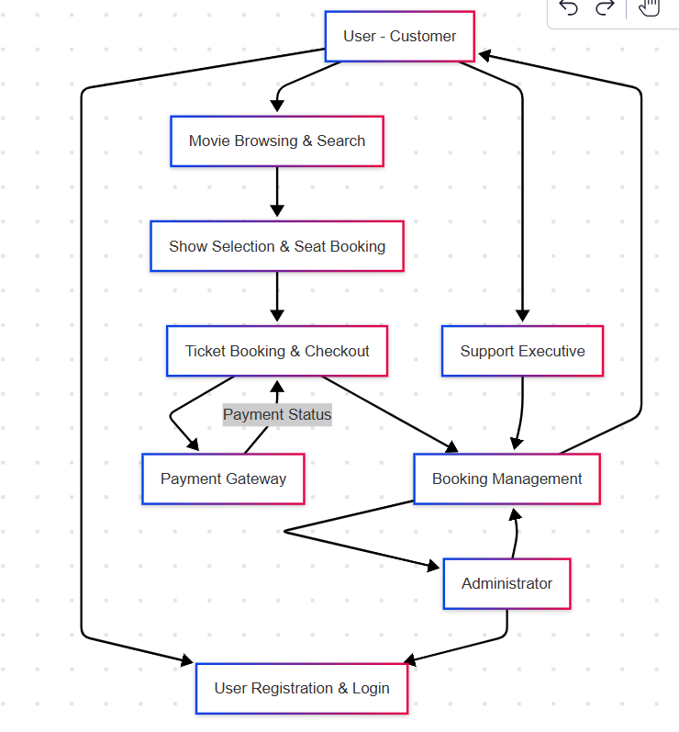

**User Stories**

|  |  |  |  |  |  |  |
| --- | --- | --- | --- | --- | --- | --- |
| **User Type** | **Functional Requirement (Epic)** | **User Story Number** | **User Story / Task** | **Acceptance Criteria** | **Priority** | **Release** |
| **Customer** | Movie Search | USN-5 | As a user, I can search for movies by title, genre, or language | Relevant movie results are displayed in real-time | High | Sprint-2 |
| **Customer** | Show & Seat Selection | USN-6 | As a user, I can select a showtime and available seat(s) for a movie | Seat map is interactive and reflects live availability | High | Sprint-2 |
| **Customer** | Booking & Payment | USN-7 | As a user, I can proceed to book and make payment securely | Booking is confirmed and receipt/ticket is generated | High | Sprint-2 |
| **Customer** | Booking History | USN-8 | As a user, I can view my past bookings | Previous bookings with movie, date, and seat details are listed | Medium | Sprint-3 |
| **Customer** | Ticket Download | USN-9 | As a user, I can download or view my e-tickets after successful payment | Ticket shows QR, movie name, seat, date, and time | Medium | Sprint-3 |
| **Customer** | Support | USN-10 | As a user, I can contact support via a form or chat | Ticket/chat is visible to support staff | Medium | Sprint-4 |
| **Admin** | Movie Management | USN-11 | As an admin, I can add/edit/delete movies and showtimes | Changes reflect on the platform in real-time | High | Sprint-1 |
| **Admin** | Booking Monitoring | USN-12 | As an admin, I can view and manage all bookings | Bookings are listed with user info and status | Medium | Sprint-3 |
| **Admin** | User Management | USN-13 | As an admin, I can manage registered user accounts | Admin can ban, reset, or view user activity | Medium | Sprint-3 |
| **Support Agent** | Support Management | USN-14 | As a support agent, I can view and respond to support tickets | Agents can see open tickets, user info, and reply | High | Sprint-4 |